Bubble Sort

Concept :-

If sorting is to be done in ascending order, then bubble sort will start by comparing the first element with the second element, if the first element is greater than the second element, it will swap them, and then compare it with the second and the third element, and so on. With every complete iteration the largest element in the given array, is placed at the last place or the highest index.

State the problem clearly. Identify the input & output formats.

Problem
We need to write a function to sort a list of numbers in increasing order.

Input
- nums: A list of numbers e.g. [4, 5, 3, 2, 1]

Output
- sorted_nums: The sorted version of nums e.g. [1, 2, 3, 4, 5]
Finding Solution :

It's easy to come up with a correct solution. Here's one:
- Iterate over the list of numbers, starting from the left
- Compare each number with the number that follows it
- If the number is greater than the one that follows it, swap the two elements
- Repeat steps 1 to 3 till the list is sorted.
We need to repeat steps 1 to 3 at most n-1 times to ensure that the array is sorted. Can you explain why? Hint: After one iteration, the largest number in the list.
This method is called bubble sort, as it causes smaller elements to bubble to the top and larger to sink to the bottom. Here's a visual representation of the process:
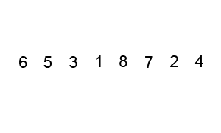

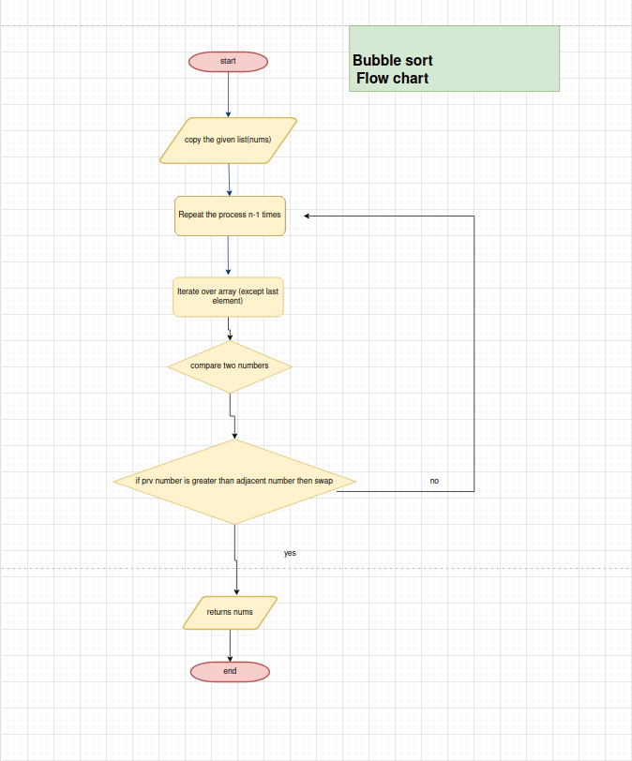

In the above algorithm,
- We first read the array from the user.
- We start by comparing the first element of the array with the second element, and in case if the first element is greater than the second element, we will swap both the elements, and then move on to compare the second and the third element, and continue till the end so on.
- If the first element is lesser than the second element then we move to the second and compare it with the third element and move so on.
- In case the is greater we follow the step 4 and if it'sless we follow step 5. Both of the are discussed above.
- We follow the same process until the given array is sorted.

Code:-
def bubble_sort(nums):
# Create a copy of the list, to avoid changing it
nums = list(nums)

# 4. Repeat the process n-1 times
for _ in range(len(nums) - 1):

# 1. Iterate over the array (except last element)
for i in range(len(nums) - 1):

# 2. Compare the number with
if nums[i] > nums[i+1]:

# 3. Swap the two elements
nums[i], nums[i+1] = nums[i+1], nums[i]

# Return the sorted list
return nums

Calculate Time Complexity
The core operations in bubble sort are "compare" and "swap". To analyze the time complexity, we can simply count the total number of comparisons being made, since the total number of swaps will be less than or equal to the total number of comparisons ,here are two loops, each of length n-1, where n is the number of elements in nums. So the total number of comparisons is
(n-1) * (n-1)= (n-1) ^ 2
we can conclude that the time complexity of bubble sort is O(n ^ 2).
.
Expressing this in the Big O notation, we can conclude that the time complexity of bubble sort is O(n ^ 2)
(also known as quadratic complexity).

Data structure | Array
Worst-case performance | O(n ^ 2) comparisons, swaps
Best-case performance | O (n) comparisons, swaps
Average performance | O(n ^ 2) comparisons, swaps
Worst-case space complexity | O(n ) , O(1)

Note :- The inefficiency in bubble sort goes from the fact that we're shifting elements by at most one position at a time.

